Theory of Knowledge
To what extent are we obligated to act on knowledge of universally accepted immoral behavior?
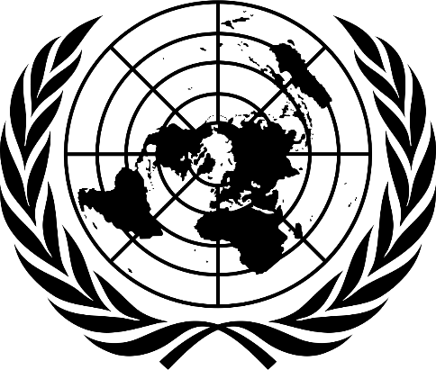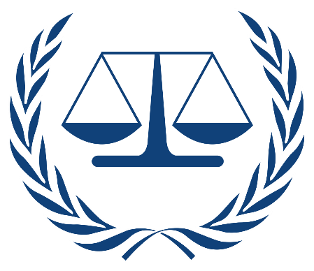
Address the following tasks in your journal.
- After Nuremberg, Eleanor Roosevelt was appointed to the United Nations by President Truman to work with member nations to codify an internationally accepted categorical imperative – the UN Declaration of Human rights. Open the attachment below:
  - https://www.un.org/en/udhrbook/pdf/udhr_booklet_en_web.pdf
  - Using this illustrated copy of the UN Declaration of Human Rights, write down the 5 most important rights that you feel the international community should fight to protect. Why did you select these five? Explain.
- The United Nations and many other nations around the world – have attempted to apply Justice Jackson’s vision for judicial accountability by use War Crimes and Crimes against Humanity as benchmarks for holding nations and/or individual leaders accountable for internationally defined criminal acts.
- Using credible on-line sources, including our library subscription databases research and summarize your findings for the following questions:
    - How were the UN International Tribunals established?
    - These tribunals opened proceeding in 2 war torn countries.
      - Former Yugoslavia
      - Rwanda
    - Explain the evidence for war crimes and crimes against humanity collected by the Tribunals for each country.
    - Summarize the outcomes of both cases.
- Describe some of the circumstances and outcomes from the UN Special Court for Sierra Leone.
- What is the International Criminal Court?
      - How is this institution different from those courts under UN jurisdiction?
      - Is the United States a member of the International Criminal Court?

