WANTED
Omar al-Bashir

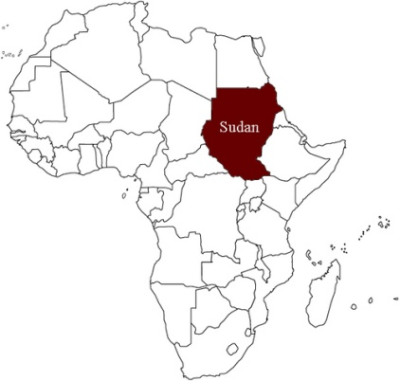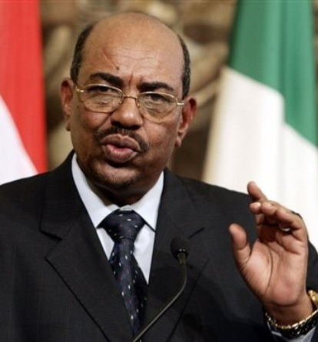

Text | Annotate
Omar al-Bashir is the current President of Sudan and head of the National Congress Party. He is also the first sitting head of state to be indicted by the ICC. Al-Bashir came to power in 1989 when he led a group of officers in a military coup that ousted the government.  During his presidency, there have been several violent struggles between the Janjaweed militia and rebel groups such as the Sudan People's Liberation Army (SPLA), Sudanese Liberation Army (SLA) and the Justice and Equality Movement (JEM) in the form of guerilla warfare in the Darfur region. Since 2003 violent conflict in Darfur has resulted in 2.5 million people reportedly being displaced and death tolls estimated at between 200,000 and 400,000.  Despite the fact that Al-Bashir's ruling National Congress Party warned of "more violence and blood" if an arrest warrant was issued against the President, the ICC issued a warrant for al-Bashir on March 4, 2009 for crimes against humanity and war crimes, including murder, extermination and rape. The arrest warrant states that Sudanese government forces "subjected hundreds of thousands of civilians, belonging primarily to the Fur, Masalit and Zaghawa groups, to acts of forcible transfer... thousands of civilian women, belonging primarily to these groups, to acts of rape; and ...civilians, belonging primarily to the same groups, to acts of torture."  Al-Bashir has been accused of recruiting, arming and purposefully failing to disarm the Janjaweed militia, which has committed gross crimes across the country. He is accused of overseeing the incorporation of the Janjaweed militia into the reserve forces, and also of exercising formal and informal control over such forces. ICC Chief Prosecutor, Luis Moreno-Ocampo, has spoken of women ranging from 6 to 70 years of age being raped under the Sudanese government's watch. One witness said of the Janjaweed militia and other government "security" forces: "when we see them, we run. Some of us succeed in getting away, and some are caught and taken to be raped - gang-raped. These things are normal for us here in Darfur. These things happen all the time. I have seen rapes too. It does not matter who sees them raping the women -- they don't care. They rape women in front of their mothers and fathers". The Sudanese government has refused to cooperate with the ICC and has stated that it will not hand Al-Bashir over to the Court.  The ICC's decision to issue an arrest warrant for Al-Bashir has brought criticisms from the African Union, League of Arab States and the Non-Alignment Movement. Those opposed to the arrest warrant have stated that it will be an impediment to peace in the region. However, while in power Al-Bashir has continued to act with brazen impunity, undermining any realistic chance for peace and undermining the stability of the region. | Define: Coup  Janjaweed: A nomadic Arab tribal militia from the Darfur region of western Sudan; typically armed with guns and riding on camels or horses, accused of ethnic cleansing of non-Arab people.  What did his political party warn?  What crimes is Bashir accused of?  How does Bashir use the Janjaweed?  Why are some opposed to his arrest warrant?  Impunity: exemption or freedom from punishment, harm, or loss.

DRIECTIONS: You are a lawyer who has been assigned to prosecute a war crimes trial at the International Criminal Court. Write an opening statement for the case against the perpetrator described above. When doing this, please include the following:
- Identify the perpetrator(s) of the abuse
- The charges against the perpetrator
- A description of the human rights abuse and why it should be considered a crime
- Identify the victims
- Remember, you are trying to convince your audience of the guilt of the perpetrator based on the information you present

_______________________________________________________________________________________________________________________________________________________________________________________________________________________________________________________________________________________________________________________________________________________________________________________________________________________________________________________________________________________________________________________________________________________________________________________________________________________________________________________________________________________________________________________________________________________________________________________________________________________________________________________________________________________________________________________________________________________________________________________________________________________________________________________________________________________________________________________________________________________________________________________________________________________________________________________________________________________________________________________________________________________________________________________________________________________________________________________________________________________________________________________________________________________________________________________________________________________________________________________________________________________________________________________________________________________________________________________________________________________________________________________________________________________________________________________________________________________________________________________________________________________________________________________________________________________________________________________________________________________________________________________________________________________________________________________________________________________________________________________________________________________________________________________________________________________________________________________________________________________________________________________________________________________________________________________________________________________________________________________________________________________________________________________________________________________________________________________________________________________________________________________________________________________________________________________________________________________________________________________________________________________________________________________________________________________________________________________________________________________________________________________________________________________________________________________________________________________________________________________________________________________________________________________________________________________________________________________________________________________________________________________________________________________________________________________________________________________________________________________________________________________________________________________________________________________________________________________________________________________________________________________________________________________________________________________________________________________________________________________________________________________________________________________________________________________________________________________________________________________________________________________________________________________________________________________________________________________________________________________________________________________________________________________________________________________________________________________________________________________________________________
WANTED
Joseph Kony

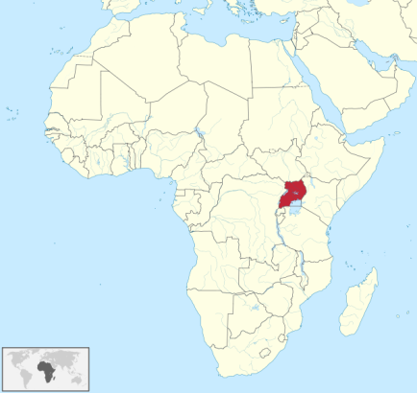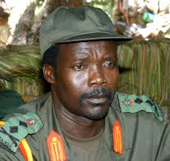

Text | Annotate
Joseph Kony is the head of the Lord's Resistance Army [LRA], a guerrilla group reportedly engaged in a violent campaign to establish a theocratic government in Uganda. The LRA is accused of committing murder, abduction, mutilation, sexual enslavement of women and children, and forcing children to participate in hostilities.  On October 6, 2005, the ICC issued an arrest warrant for Kony, along with four other members of the LRA. There are 33 charges against him, including 12 counts of crimes against humanity (murder, enslavement, sexual enslavement and rape) and 21 counts of war crimes (including murder, intentionally directing an attack against a civilian population, pillaging, inducing rape, and forced enlisting of children into the rebel ranks).  The LRA was formed in 1987 and is engaged in an armed rebellion against the Ugandan government- one of the longest-running conflicts in Africa. Kony leads the LRA, and proclaims himself to be a "spokesperson" of God. Kony has told reporters that he would not be willing to stand trial at the ICC because he had not done anything wrong. When asked about the child soldiers he had enlisted, he responded, "We don't have any children. We only have combatants." Among the allegations against the LRA is the kidnapping of an estimated 20,000 children for use as soldiers or sex slaves and the use of young girls as "wives" for military commanders- the higher the post, the more "wives" are given. Kony himself is reputed to have 60 "wives."  Additionally, the LRA has reportedly been using boys as decoys and targets, often sent unarmed to the front lines when the LRA is fighting the Ugandan army. Recruits are allegedly brutally tortured for resisting the LRA, and punishments include having their noses, lips and ears cut off. Victims have also talked about being made to eat their own flesh. Kony is accused of ritually sacrificing children.  One victim of Kony's brutality recalls: "They arrested many ... Two men were tied and forced onto the ground where their heads were joined together. The rebels tried to force me to pick up a log and hit their heads but I refused so one came for me with a knife and cut off my left ear... For a long time, the rebels took turns at beating us men with hot metal... They then cut off my right ear and my nose... They returned to me at some point and re-tied me before chopping off my lips... My wounds had begun to rot...I insulted their commander in the hope that in revenge he would kill me... He just ordered his soldiers to cut off my hands. They did... | Define: theocratic  What are the charges against Kony?  How does Kony characterize child soldiers?  What are happens if you resist the LRA?

DRIECTIONS: You are a lawyer who has been assigned to prosecute a war crimes trial at the International Criminal Court. Write an opening statement for the case against the perpetrator described above. When doing this, please include the following:
- Identify the perpetrator(s) of the abuse
- The charges against the perpetrator
- A description of the human rights abuse and why it should be considered a crime
- Identify the victims
- Remember, you are trying to convince your audience of the guilt of the perpetrator based on the information you present

_______________________________________________________________________________________________________________________________________________________________________________________________________________________________________________________________________________________________________________________________________________________________________________________________________________________________________________________________________________________________________________________________________________________________________________________________________________________________________________________________________________________________________________________________________________________________________________________________________________________________________________________________________________________________________________________________________________________________________________________________________________________________________________________________________________________________________________________________________________________________________________________________________________________________________________________________________________________________________________________________________________________________________________________________________________________________________________________________________________________________________________________________________________________________________________________________________________________________________________________________________________________________________________________________________________________________________________________________________________________________________________________________________________________________________________________________________________________________________________________________________________________________________________________________________________________________________________________________________________________________________________________________________________________________________________________________________________________________________________________________________________________________________________________________________________________________________________________________________________________________________________________________________________________________________________________________________________________________________________________________________________________________________________________________________________________________________________________________________________________________________________________________________________________________________________________________________________________________________________________________________________________________________________________________________________________________________________________________________________________________________________________________________________________________________________________________________________________________________________________________________________________________________________________________________________________________________________________________________________________________________________________________________________________________________________________________________________________________________________________________________________________________________________________________________________________________________________________________________________________________________________________________________________________________________________________________________________________________________________________________________________________________________________________________________________________________________________________________________________________________________________________________________________________________________________________________________________________________________________________________________________________________________________________________________________________________________________________________________________________________________________
WANTED
Bosco Ntaganda

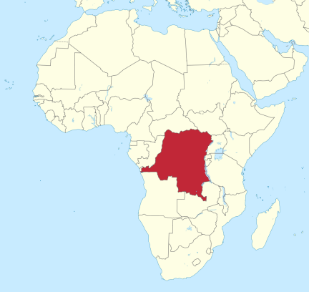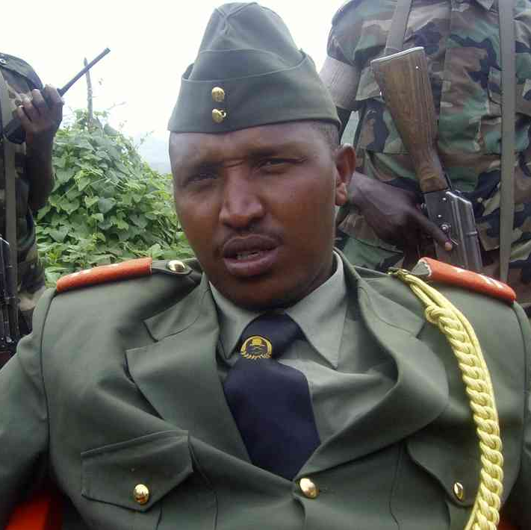

Text | Annotate
Bosco Ntaganda is a former member of the Rwandan Patriotic Army and allegedly a former Deputy Chief of the General Staff of the Forces Patriotiques pour la Liberation du Congo (FPLC). He is allegedly the top recruiter and trainer of child soldiers. He had command over training facilities in Bule, Cantrale, Mandro, Rwampara, Irumu, Bogoro and Sota.  Additionally, he is accused of taking part in FPLC attacks where the group used child soldiers. In May 2008, the ICC issued an arrest warrant for Ntaqanda. The warrant states that Ntaganda is accused of "enlisting into the FPLC, conscripting into the FPLC and using to participate actively in hostilities children under the age of fifteen ... within the context of and in association with the conflict in Ituri." The militia has been accused of using sexual violence as a weapon of war, grabbing pupils from schools, and conscripting them into its ranks. Ntaganda is a co-accused in the trial of Thomas Lubanga, another Congo militia leader, which began on January 26. At The Hague, one child testified that Ntaganda is the one who gave orders to soldiers who kidnapped him and several other children, and that he regularly inspected their training camp.  The authorities in the DRC issued an arrest warrant for Ntaganda in April 2005 for allegedly committing torture, assassination, illegal detention and arbitrary arrest. Ntaganda was also allegedly involved in incidents involving peacekeepers in 2004, namely the kidnapping of a Moroccan peacekeeper and the murder of a Kenyan peacekeeper. There are also suggestions that he was implicated in the killing of two aid workers in the DRC, according to the Human Rights Watch website.  In addition to the ICC charges, Ntaganda has been accused of commanding troops that massacred 150 civilians at Kiwanja in North Kivu province in November 2008. Ntaganda also commanded troops accused of having killed at least 800 civilians on an ethnic basis in the town of Mongbwalu and Kiwanja. "A girl, who told the court she was conscripted at the age of 13 and about the fighting in Mongbwalu said that '[there was lots of money and gold mining, so we had to stay in Mongbwalu for a long time.'"  "They broke the door and they took my husband. First they took him out, and then questioned him to give money. And then he [gave] them 400 dollars. And that was all his money then they asked him again to give telephone. He said 'I don't have telephone, I don't have radio.' The rebels brought him back inside.' Next the rebels went next door and killed the neighbors..."  Ntaganda remains at large, and is currently the military Chief of Staff of the National Congress for the Defense of the People (CNDP), an armed militia group operating in the North Kivu province of the DRC. In 2009 the CNDP militias were integrated into the Congolese army [FARDCJ, where Ntaganda remains a General. | FLPC: Patriotic Force for the Liberation of Congo  What is Ntganda accused of doing?  What evidence is there against Ntaganda?  Why were the civilians massacred in Mongbwalu and Kiwanja?  Define: “at large”

DRIECTIONS: You are a lawyer who has been assigned to prosecute a war crimes trial at the International Criminal Court. Write an opening statement for the case against the perpetrator described above. When doing this, please include the following:
- Identify the perpetrator(s) of the abuse
- The charges against the perpetrator
- A description of the human rights abuse and why it should be considered a crime
- Identify the victims
- Remember, you are trying to convince your audience of the guilt of the perpetrator based on the information you present

_______________________________________________________________________________________________________________________________________________________________________________________________________________________________________________________________________________________________________________________________________________________________________________________________________________________________________________________________________________________________________________________________________________________________________________________________________________________________________________________________________________________________________________________________________________________________________________________________________________________________________________________________________________________________________________________________________________________________________________________________________________________________________________________________________________________________________________________________________________________________________________________________________________________________________________________________________________________________________________________________________________________________________________________________________________________________________________________________________________________________________________________________________________________________________________________________________________________________________________________________________________________________________________________________________________________________________________________________________________________________________________________________________________________________________________________________________________________________________________________________________________________________________________________________________________________________________________________________________________________________________________________________________________________________________________________________________________________________________________________________________________________________________________________________________________________________________________________________________________________________________________________________________________________________________________________________________________________________________________________________________________________________________________________________________________________________________________________________________________________________________________________________________________________________________________________________________________________________________________________________________________________________________________________________________________________________________________________________________________________________________________________________________________________________________________________________________________________________________________________________________________________________________________________________________________________________________________________________________________________________________________________________________________________________________________________________________________________________________________________________________________________________________________________________________________________________________________________________________________________________________________________________________________________________________________________________________________________________________________________________________________________________________________________________________________________________________________________________________________________________________________________________________________________________________________________________________________________________________________________________________________________________________________________________________________________________________________________________________________________________________________
WANTED
Ali Kushayb

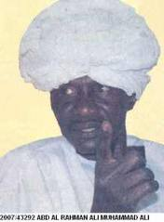

Text | Annotate
Ali Kushayb is a former senior Janjaweed commander, and has been referred to as the "Colonel of Colonels"; he commanded thousands of men that operated in the Darfur region. Not only does Kushayb command thousands of Janjaweed militia men in the southwestern part of West Darfur. but he also holds an officer's rank in the Sudanese military. He has a warrant out for his arrest by the ICC and Interpol has issued a Red Notice.  The ICC Prosecutor has accused Kushayb of attacking and murdering civilians in 2003 and 2004, as well as ordering numerous rapes, killings, and lootings. The crimes investigated by the ICC Prosecutor took place during attacks on the villages of Kodoom, Bindisi, Mukjar, and Arawala in West Darfur between August 2003 and March 2004. The ICC has charged Kushayb with 504 assassinations, 20 rapes, and the forced displacement of 41,000 people. Kushayb was reported to have led raids that left hundreds dead and countless homes destroyed.  In December 2003 in the town of Arawala, a witness reported Kushayb inspecting her and other women who had been tied to a tree naked to be raped repeatedly by Janjaweed militia soldiers.[14] As with other attacks. Kushayb's alleged attack on Bindisi used rape as a way to terrorize and degrade women because of their race. According to an eyewitness;  While carrying out the rapes, the attackers were saying, "We have taken Tora Bora's wives, praise be to God."  Kushayb was arrested by the Sudanese government in October 2008 but was not surrendered to the ICC. The ICC will have to determine the genuineness of the criminal proceedings involving Kushayb in Sudan to decide whether he could be tried by the ICC. Today Kushayb is still considered a fugitive wanted by the ICC. | Janjaweed: A nomadic Arab tribal militia from the Darfur region of western Sudan; typically armed with guns and riding on camels or horses, accused of ethnic cleansing of non-Arab people.  What are the charges against Kushayb?  What happened in 2008?  Define: fugitive

DRIECTIONS: You are a lawyer who has been assigned to prosecute a war crimes trial at the International Criminal Court. Write an opening statement for the case against the perpetrator described above. When doing this, please include the following:
- Identify the perpetrator(s) of the abuse
- The charges against the perpetrator
- A description of the human rights abuse and why it should be considered a crime
- Identify the victims
- Remember, you are trying to convince your audience of the guilt of the perpetrator based on the information you present

_______________________________________________________________________________________________________________________________________________________________________________________________________________________________________________________________________________________________________________________________________________________________________________________________________________________________________________________________________________________________________________________________________________________________________________________________________________________________________________________________________________________________________________________________________________________________________________________________________________________________________________________________________________________________________________________________________________________________________________________________________________________________________________________________________________________________________________________________________________________________________________________________________________________________________________________________________________________________________________________________________________________________________________________________________________________________________________________________________________________________________________________________________________________________________________________________________________________________________________________________________________________________________________________________________________________________________________________________________________________________________________________________________________________________________________________________________________________________________________________________________________________________________________________________________________________________________________________________________________________________________________________________________________________________________________________________________________________________________________________________________________________________________________________________________________________________________________________________________________________________________________________________________________________________________________________________________________________________________________________________________________________________________________________________________________________________________________________________________________________________________________________________________________________________________________________________________________________________________________________________________________________________________________________________________________________________________________________________________________________________________________________________________________________________________________________________________________________________________________________________________________________________________________________________________________________________________________________________________________________________________________________________________________________________________________________________________________________________________________________________________________________________________________________________________________________________________________________________________________________________________________________________________________________________________________________________________________________________________________________________________________________________________________________________________________________________________________________________________________________________________________________________________________________________________________________________________________________________________________________________________________________________________________________________________________________________________________________________________________________________________________
WANTED
Okol Odhiambo

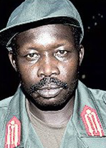

Text | Annotate
Okol Odhiambo was named Deputy Army Commander of the LRA after the apparent death of Vincent Otti. In October 2007.  He was also a member of the "Control Altar," the core leadership group responsible for devising and implementing LRA strategy. Odhiambo was rumored to have died in 2008, however, his name remains on the ICC case.  The ICC arrest warrant describes Odhiambo as a "ruthless killer." the "one who killed the most," and a "bitter man who would kill anyone." ICC Chief Prosecutor, Luis Moreno-Ocampo, said that Odhiambo commanded the most violent of the four brigades of the LRA.  He has allegedly led many violent massacres, including the 2004 Barlonyo Massacre at a camp for internally displaced persons where 300 villagers were burnt, shot, and hacked to death in three hours. On July 8, 2005, the ICC issued Odhiambo's arrest warrant, and charged him with three counts of crimes against humanity and seven counts of war crimes.  On January 29, 2009, Odhiambo announced his intention to defect from the LRA and return to Uganda if the government would agree to not send him to the ICC. Henry Okello Oryem, Uganda's state minister for international relations, has said that the ICC indictment will not be discussed until Odhiambo is in custody. | What is Odhiambo charged with?  What deal did Odhiambo attempt to negotiate to avoid the ICC?

DRIECTIONS: You are a lawyer who has been assigned to prosecute a war crimes trial at the International Criminal Court. Write an opening statement for the case against the perpetrator described above. When doing this, please include the following:
- Identify the perpetrator(s) of the abuse
- The charges against the perpetrator
- A description of the human rights abuse and why it should be considered a crime
- Identify the victims
- Remember, you are trying to convince your audience of the guilt of the perpetrator based on the information you present
_______________________________________________________________________________________________________________________________________________________________________________________________________________________________________________________________________________________________________________________________________________________________________________________________________________________________________________________________________________________________________________________________________________________________________________________________________________________________________________________________________________________________________________________________________________________________________________________________________________________________________________________________________________________________________________________________________________________________________________________________________________________________________________________________________________________________________________________________________________________________________________________________________________________________________________________________________________________________________________________________________________________________________________________________________________________________________________________________________________________________________________________________________________________________________________________________________________________________________________________________________________________________________________________________________________________________________________________________________________________________________________________________________________________________________________________________________________________________________________________________________________________________________________________________________________________________________________________________________________________________________________________________________________________________________________________________________________________________________________________________________________________________________________________________________________________________________________________________________________________________________________________________________________________________________________________________________________________________________________________________________________________________________________________________________________________________________________________________________________________________________________________________________________________________________________________________________________________________________________________________________________________________________________________________________________________________________________________________________________________________________________________________________________________________________________________________________________________________________________________________________________________________________________________________________________________________________________________________________________________________________________________________________________________________________________________________________________________________________________________________________________________________________________________________________________________________________________________________________________________________________________________________________________________________________________________________________________________________________________________________________________________________________________________________________________________________________________________________________________________________________________________________________________________________________________________________________________________________________________________________________________________________________________________________________________________________________________________________________________________________________________

